**IoT Water Control and Monitor Using NodeMCU & Cayenne**

I'll try to create IoT water control and can be monitoring using Cayenne.

[Beginner](https://www.hackster.io/projects?difficulty=beginner)Showcase (no instructions)1 hour4,639

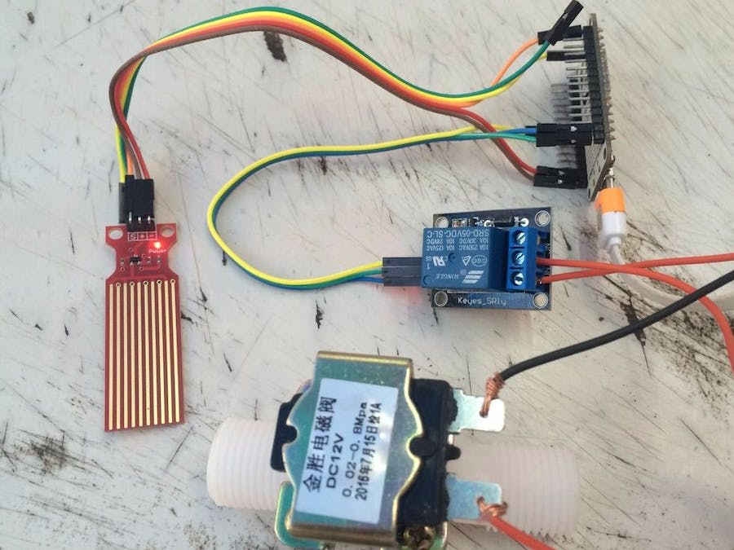

**Things used in this project**

|  |  |  |  |  |  |
| --- | --- | --- | --- | --- | --- |
| **Hardware components** | | | | | |
| NodeMCU ESP8266 Breakout Board | |  | | --- | | [NodeMCU ESP8266 Breakout Board](https://www.hackster.io/nodemcu/products/nodemcu-esp8266-breakout-board?ref=project-b37015) | |  | | × | 1 |  |  |
|  | |  | | --- | | Liquid Level Sensor | |  | | × | 1 |  |  |
|  | |  | | --- | | Adafruit Plastic Water Solenoid Valve - 12V - 1/2" | |  | | × | 1 |  |  |
|  | |  | | --- | | Relay (generic) | |  | | × | 1 |  |  |
|  | |  | | --- | | Power Supply 12V/2A | |  | | × | 1 |  |  |
| **Software apps and online services** | | | | | |
| Arduino IDE | |  | | --- | | [Arduino IDE](https://www.hackster.io/arduino/products/arduino-ide?ref=project-b37015) | |  | |  | |  |  |
| Cayenne | |  | | --- | | [myDevices Cayenne](https://www.hackster.io/mydevices/products/cayenne?ref=project-b37015) | |  | |  | |  |  |

**Story**

I'll try to create IoT water control and can be monitoring using Cayenne.

The valve will close when water reached top level of the sensor.

This project is to ensure that water reservoir always in full condition, because in my location the water supply only flow when midnight, but if midnight we are not need water.

**Code**

**WATER_CONTROL.ino**

C/C++

#include "CayenneDefines.h"

#include "CayenneWiFi.h"

#include "CayenneWiFiClient.h"

#define CAYENNE_PRINT Serial // Comment this out to disable prints and save space

#define RELAY_PIN 14 // RELAY PIN

const int sensorPin= A0; //sensor pin connected to analog pin A0

float liquid_level;

int liquid_percentage;

int top_level = 512; //calibrate the top level of sensor

int bottom_level = 3; //calibrate the bottom level of sensor

// Cayenne authentication token. This should be obtained from the Cayenne Dashboard.

char token[] = ""; // Insert your token here

char ssid[] = ""; // Insert your SSID here

char pwd[] = ""; // Insert your SSID password here

void setup() {

Serial.begin(115200);

Cayenne.begin(token, ssid, pwd);

pinMode(sensorPin, INPUT);

pinMode(RELAY_PIN, OUTPUT);

}

void loop() {

liquid_level = analogRead(sensorPin);

liquid_percentage = ((liquid_level-bottom_level)/top_level)*100;

Serial.println(liquid_level);

delay(100);

Cayenne.run();

}

CAYENNE_OUT(V10)

{

Cayenne.virtualWrite(V10, liquid_percentage);

}

CAYENNE_IN(V1)

{

// get value sent from dashboard

int currentValue = getValue.asInt(); // 0 to 1

// assuming you wire your relay as normally open

if (currentValue == 0) {

digitalWrite(RELAY_PIN, HIGH);

} else {

digitalWrite(RELAY_PIN, LOW);

}

}

**Credits**

[](https://www.hackster.io/kuncono)

[**Kuncono Liem**](https://www.hackster.io/kuncono)

7 projects • 9 followers

Follow[**Contact**](https://www.hackster.io/users/sign_up?redirect_to=%2Fmessages%2Fnew%3Frecipient_id%3D116435&source=user_contact)

**Comments**

Please [log in](javascript:void(0);) or [sign up](javascript:void(0);) to comment.

**Solenoid Valve Interfacing With Arduino**

July 15, 2021 by [Admin](https://techatronic.com/author/shahid/)

Table of Contents

[](https://techatronic.com/solenoid-valve-interfacing-with-arduino/)

* [Introduction](https://techatronic.com/solenoid-valve-interfacing-with-arduino/#Introduction)
* [What is a Solenoid Valve](https://techatronic.com/solenoid-valve-interfacing-with-arduino/#What_is_a_Solenoid_Valve)
* [How Does it Work?](https://techatronic.com/solenoid-valve-interfacing-with-arduino/#How_Does_it_Work)
* [Components Required](https://techatronic.com/solenoid-valve-interfacing-with-arduino/#Components_Required)
* [Circuit Diagram for the Project](https://techatronic.com/solenoid-valve-interfacing-with-arduino/#Circuit_Diagram_for_the_Project)
  + [Connection Table](https://techatronic.com/solenoid-valve-interfacing-with-arduino/#Connection_Table)
* [Code for the Project](https://techatronic.com/solenoid-valve-interfacing-with-arduino/#Code_for_the_Project)
* [Video sample](https://techatronic.com/solenoid-valve-interfacing-with-arduino/#Video_sample)

**Introduction**

Hey guys, welcome back to Techatronic. In this article, we are going to discuss the **interfacing of a Solenoid valve with the Arduino**.

You have to provide the supply of liquid for which you want to control the flow on the one end of the solenoid valve.

this is the same as our previous article Arduino solenoid lock interface. Just leave the other end or you can also connect a pipe to it as per your requirements.

When the power is turned off the liquid will not flow from the other end of the valve is in the off position. To turn the supply on you have to provide the power.

The solenoid valve is the same as the manual valve. if you know the manual valve. there is a lever that helps you to on and off the supply. in this Arduino Tutorial, we will describe how does the Arduino interface with the solenoid lock. there are two types of valve water valve and air valve.

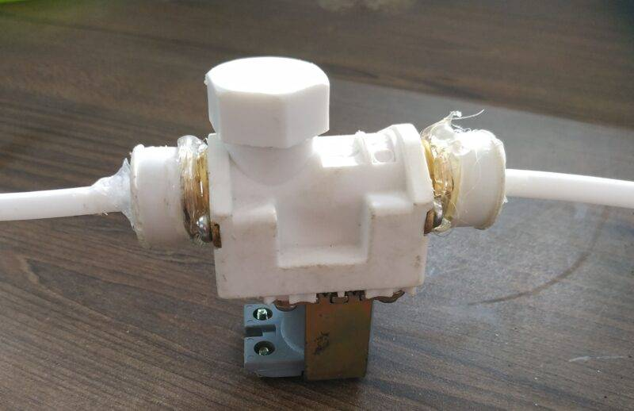

**What is a Solenoid Valve**

Just like the valves used in your homes for controlling the flow of the water a solenoid valve is used to serve the same purpose.

The main difference between an ordinary valve and a solenoid valve is that a **solenoid valve** can operate automatically.

You can program it to work automatically according to the given instructions. you can also make [Smart Irrigation System](https://techatronic.com/smart-irrigation-system-using-arduino/)

In this project,

we use an [**Arduino UNO** microcontroller](https://techatronic.com/?s=what+is+arduino) for controlling the solenoid valve.

Mainly it is used in the industries. Inside the solenoid valve,

* there is a coil of insulated copper wire which turns into an electromagnet when you supply the power to it.
* The valve is open for the flow of liquid when the coil produces a magnetic field around it and cuts the flow when there is no power.
* The inner mechanism returns to its home position in the absence of electricity.
* A solenoid valve looks like this. As you can see at the upper part there is a coil inside the part which works on [electromagnetism](https://techatronic.com/what-is-electromagnetism/).

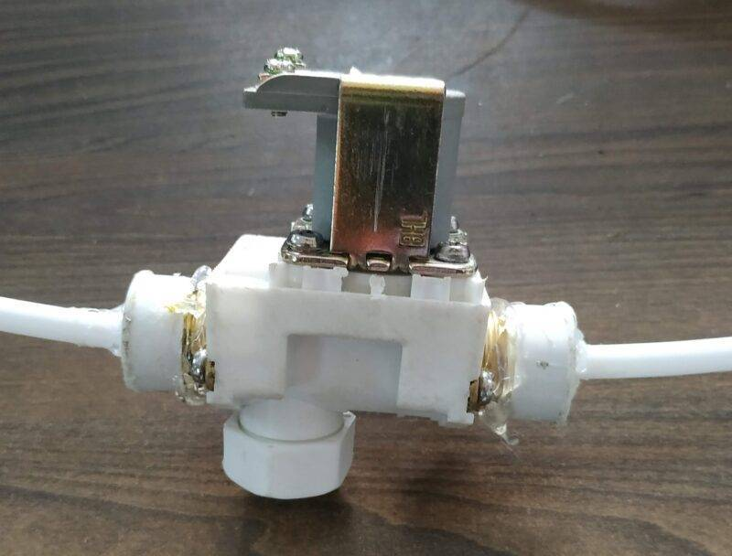

**How Does it Work?**

The solenoid valve is used for controlling the flow of any liquid. In this article, we show you the interfacing of the solenoid valve with Arduino and you can make your own projects from it.

We use a relay module here if you don’t know how to use a [relay module with Arduino](https://techatronic.com/relay-interface-with-arduino/) then check it first.

The solenoid valve can open and close automatically at a regular time interval of 1 second. Another one is the [solenoid lock](https://techatronic.com/solenoid-lock-interfacing-with-arduino/)which is used in the lock system it also operates with a program.

You can change it by modifying the code. Just complete the circuit and then upload the given code to the [Arduino UNO.](https://techatronic.com/solenoid-lock-interfacing-with-arduino/)

**Components Required**

* [Arduino UNO](https://techatronic.com/solenoid-lock-interfacing-with-arduino/)
* Solenoid valve
* [5 Volt Single-channel relay module](https://techatronic.com/solenoid-lock-interfacing-with-arduino/)
* USB cable for unloading the code
* Jumper wires
* 12-volts DC power supply
* breadboard

**Circuit Diagram for the Project**

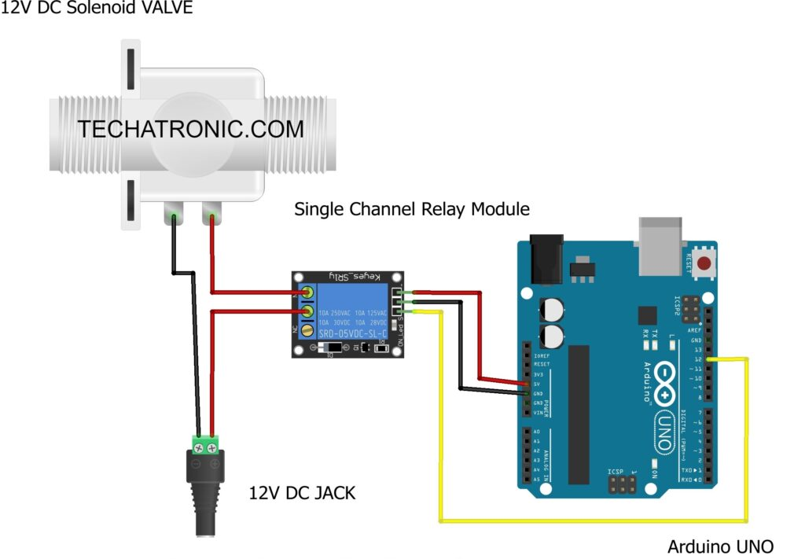

Connection Table

|  |  |
| --- | --- |
| Arduino UNO | 5V Single Channel Relay Module |
| ( +5V ) | VCC |
| GND | GND |
| D12 Pin | IN1 Input |
| 12V DC Adaptor | Solenoid Valve | 5V Single Channel Relay Module |
|  |  | Normally Open |
| Positive |  | Common |
|  | Positive Terminal | Normally Closed |
| Negative | Negative Terminal |  |

* The circuit diagram is given above, you have to make the connections according to it.
* Connect the 5-volts pin of the [Arduino uno](https://techatronic.com/solenoid-lock-interfacing-with-arduino/)with the VCC pin of the relay module.
* Attach the GND pin of the Arduino to the GND pin of the [relay module](https://techatronic.com/solenoid-lock-interfacing-with-arduino/).
* Join the digital-12 pin of the Arduino to the IN pin of the relay module.
* On the other side of the relay module connect the positive wire of the [12-volts DC supply](https://techatronic.com/different-types-of-batteries/)and the positive wire of the solenoid valve as shown in the diagram.
* Attach the negative wire of the 12-volts DC supply to the negative wire of the solenoid valve.

Check more [**Projects on Arduino**](https://techatronic.com/category/arduino-projects/) made by us. You can also check out our [**E-book on Arduino**](https://shop.techatronic.com/index.php/arduino-ebook/) which has **10+ amazing projects** with well-explained codes.

**Code for the Project**

**NOTE**: Please [upload](https://techatronic.com/how-to-operate-arduino-software-tutorial-1/) the code given below to the Arduino as it is.

// TECHATRONIC.COM

void setup()

{

pinMode(12,OUTPUT); // RELAY PIN

digitalWrite(12,HIGH); // Normally ON Only For Chanies Relay Module

}

void loop()

{

digitalWrite(12,LOW); // RELAY ON

delay(1000);

digitalWrite(12,HIGH); // RELAY OFF

delay(1000);

}

[Solenoid Valve Interfacing With Arduino](https://techatronic.com/solenoid-valve-interfacing-with-arduino/)

[What is Electromagnetism](https://techatronic.com/what-is-electromagnetism/)

[Smart Irrigation System using Arduino](https://techatronic.com/smart-irrigation-system-using-arduino/)

[oT based Smart Irrigation](https://techatronic.com/iot-based-smart-irrigation/)

[How to automatic plant watering system](https://techatronic.com/how-to-make-smart-irrigation-project/)

We hope that you completely understand the working of the **solenoid valve with Arduino**. If you are facing any errors do inform us in the **comments section**. Please do check out more [tutorials on Arduino](https://techatronic.com/category/arduino-tutorial/) and [Raspberry pi](https://techatronic.com/category/raspberry-pi/) written by us.

**HAPPY LEARNING!**

**Video sample**

Categories[Arduino Tutorials](https://techatronic.com/category/arduino-tutorial/)Tags[12v solenoid valve](https://techatronic.com/tag/12v-solenoid-valve/), [solenoid valve](https://techatronic.com/tag/solenoid-valve/), [solenoid valve with arduino](https://techatronic.com/tag/solenoid-valve-with-arduino/)

[Temperature Monitoring System With DS18B20 And Arduino](https://techatronic.com/temperature-monitoring-system-with-ds18b20-and-arduino/)

[Solar Panel Voltage Measure project using Arduino](https://techatronic.com/solar-panel-voltage-measure-project-using-arduino/)